Investment Growth Program
Compound Interest Using Python

Student Name: Wade Chriestenson
Date: 04/19/2026

Table of Contents
Introduction
Pseudocode
Python Source Code
Program Output (Screenshots)
Git Repository Link

1. Introduction

This project calculates the growth of an investment using compound interest. The program assumes an initial investment of $1000 with an annual return of 7%. Using the compound interest formula, the program calculates how much the investment will be worth after 10, 20, and 30 years.

The program also prints the value of the investment for every year from year 1 through year 30.

Formula used:

a = p(1 + r)ⁿ

Where:
p = principal ($1000)
r = annual return (7% or 0.07)
n = number of years
a = future value of investment

2. Pseudocode

Start program

Set principal = 1000
Set rate = 0.07

Display heading for yearly growth

FOR year from 1 to 30
Calculate amount = principal × (1 + rate) ^ year
Display year and amount

Calculate year10 value
Calculate year20 value
Calculate year30 value

Display results for years 10, 20, 30

End program

3. Python Source Code
# Investment Growth Program

principal = 1000
rate = 0.07

print("Yearly Investment Growth at 7% Return")
print("-------------------------------------")

for year in range(1, 31):
amount = principal * (1 + rate) ** year
print(f"Year {year}: ${amount:.2f}")

# Specific required outputs
year10 = principal * (1 + rate) ** 10
year20 = principal * (1 + rate) ** 20
year30 = principal * (1 + rate) ** 30

print("\nRequired Results")
print("----------------")
print(f"After 10 years: ${year10:.2f}")
print(f"After 20 years: ${year20:.2f}")
print(f"After 30 years: ${year30:.2f}")

4. Program Output (Screenshots)
Screenshot 1: Terminal showing yearly output from year 1–30

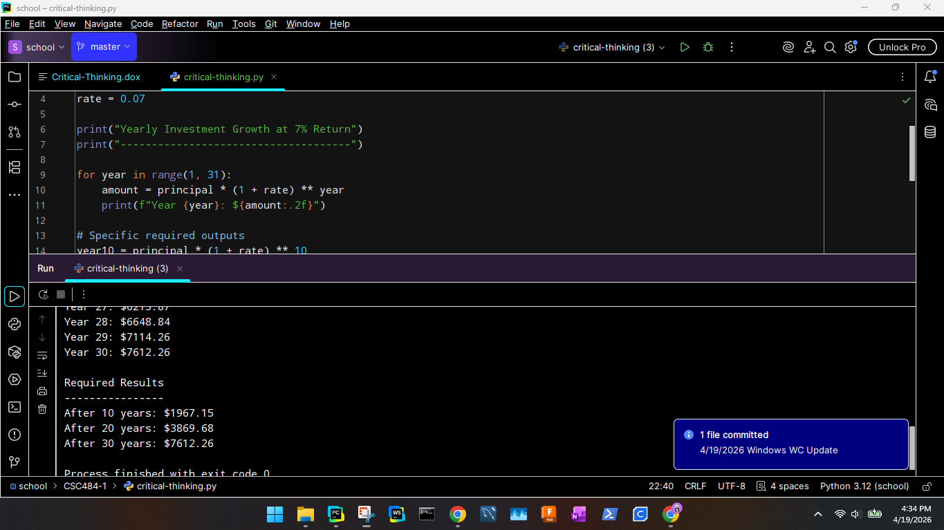

Screenshot 2: Terminal showing the final results section
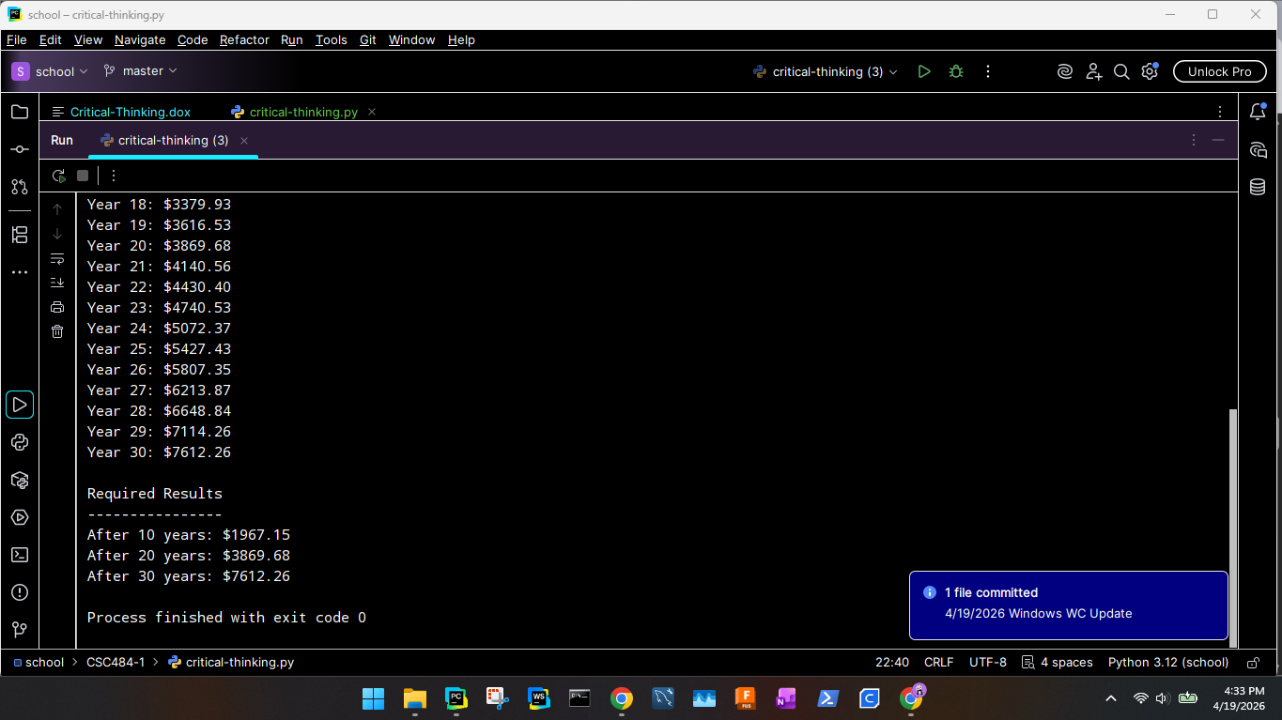

Expected final values:

After 10 years: $1,967.15
After 20 years: $3,869.68
After 30 years: $7,612.26
5. Git Repository Link

GitHub Repository URL:
https://github.com/wadeChriestenson/school-CSC484.git

